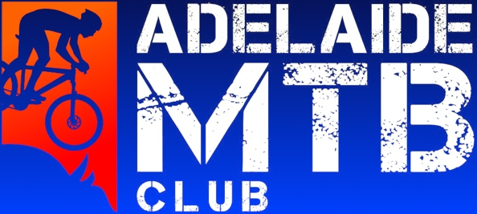
Adelaide Mountain Bike Club Grant Application for Junior funding 2024

This grant application is for any AMBC club member U23, U19, U17 or U15 who is travelling to compete at XC Nationals (Lake Macquarie); National XC rounds e.g. Gold Coast, Canberra, Brisbane or Oceania continental champs (Brisbane).

Grant funding is available for one round per applicant per season. Our grants will be $500 for up to ten applicants!

Name:

Age:

Racing category:

Contact details:

Are you an AMBC member? If so, for how many years?

Tell us your story. Some possible sentence starters here are: Why do you ride bikes are what are your goals? Do you volunteer? What is your role in the club? (1-2 paragraphs)

Please include some photos of you racing your bike so we can post on social media and format this page appropriately for your submission.

Submissions due: 26th of Jan 2024

Please email to: committee@ambc.asn.au

Successful applicants are required to provide a receipt for their entry to their selected event prior to grant funding being provided.

Funding for successful applicants will be provided by direct debit to a selected bank account.

If the selected event is cancelled for any reason, please get in touch. Applicants can generally utilise the funding for another of the selected events or return to the club for future grant opportunities.

