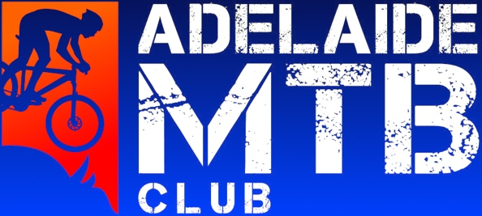
Adelaide Mountain Bike Club Grant Application for Junior funding 2023

This grant application is for any AMBC club member U19, U17 or U15 who is travelling to compete at XC Nationals (Thredbo); National XC rounds e.g. Canberra, Nerang, Harcourt or Oceania continental champs (TBA). Grant funding is available for one round per applicant per season. Our grants will be $500 for up to ten applicants!

Name:

Age:

Racing category:

Contact details:

Are you an AMBC member? If so, for how many years?

Tell us your story. Some possible sentence starters here are: Why do you ride bikes are what are your goals? Do you volunteer? What is your role in the club? (1-2 paragraphs)

Please include some photos of you racing your bike so we can post on social media and format this page appropriately for your submission.

Submissions due: 8th of Jan

Please email to: committee@ambc.asn.au

